**Operating System Lab**

**Lab Report : 04**



**Spring 2019**

**Operating System**

Submitted By : **Naveed Ahmad**

Registration No : **17PWCSE1507**

Class Section: **B**

“On my honor, as student of University of Engineering and Technology, I have neither given nor received unauthorized assistance on this academic work.”

Submitted to:

**Dr. Tariq Kamal**

March 18, 2019

**Department of Computer Systems Engineering**

**University of Engineering and Technology, Peshawar**

**Lab Report : 04**

**Basic of C Programming**

**Objective:**

To know and get Familiar with Basics C programing in Ubuntu.

**Task : 01**

**Write a C program that finds the maximum of the two numbers passed to the**

**program as command line arguments.**

**C Program :**

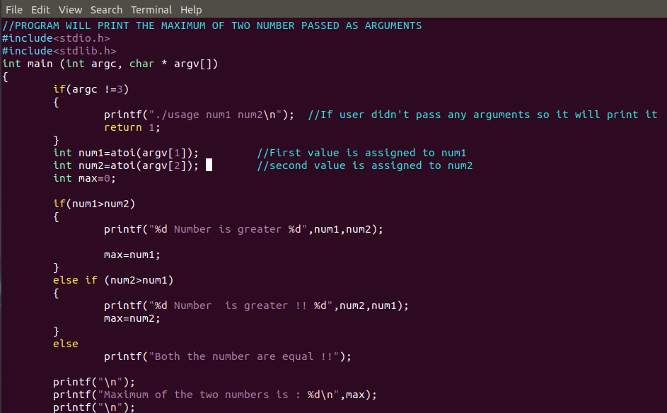

**Output :** 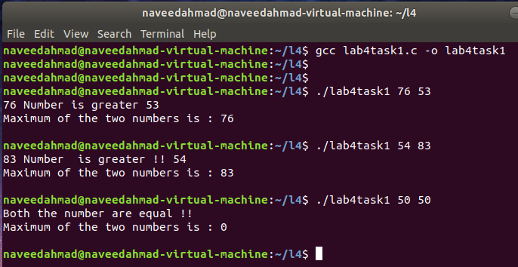

**Task : 02**

**Write a C program that declare the “PCB” structure, which contains process id,**

**status, parent process id and port number as its data members. Write an init function that**

**initializes PCB for the new process when its first created.**

**C Program :**

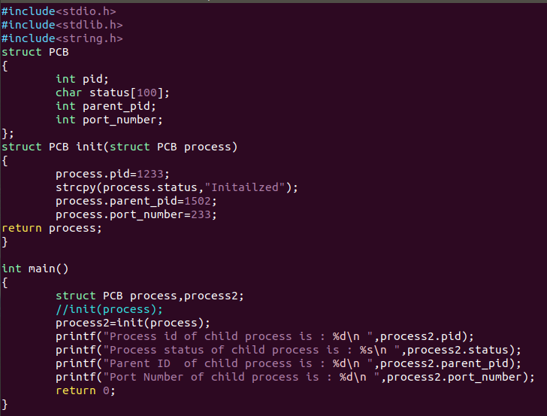

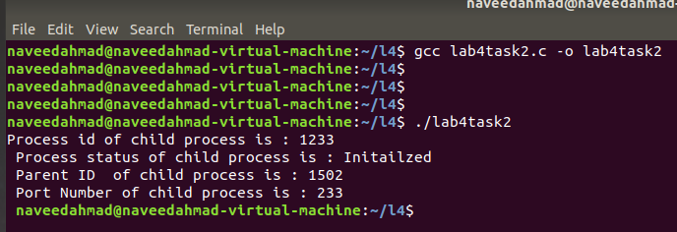**Output :**

**Task : 03**

**Write a C program that creates an array size 100. Load the array with random**

**numbers. Then sort it in descending order.**

**C Program :**

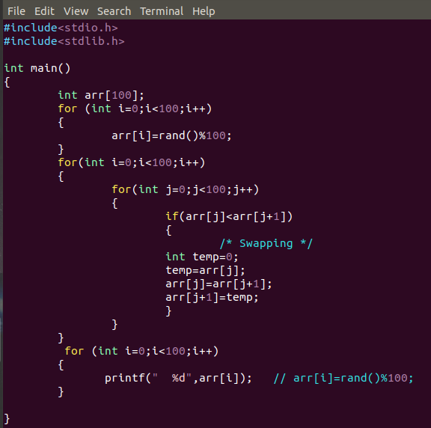

**Output :**

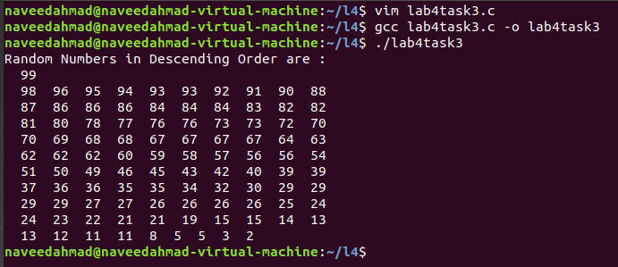

**Task : 04**

**Write a C program that counts the occurrence of word “the” in string “the quick**

**brown fox jumps over the lazy dog”.**

**C Program :**

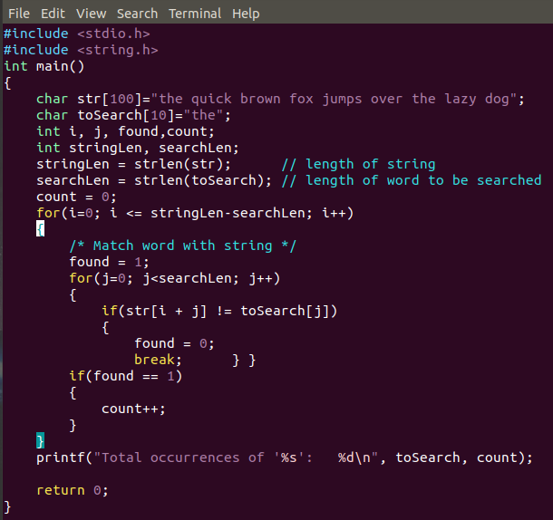

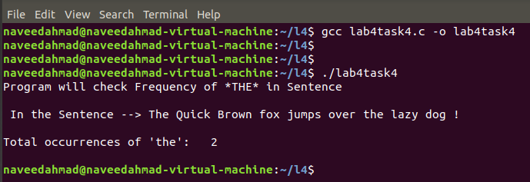**Output :**